SRM INSTITUTE OF SCIENCE AND TECHNOLOGY
DEPARTMENT OF COMPUTER SCIENCE AND ENGINEERING
KATTANKULATHUR – 603 203
15IT304J- Web Programming Register Number: RA1711003011471
Name:Manvi Singh Chandel
Experiment No: 9
Date: 19/10/2020
Aim: Design a simple online test web page in PHP

Input: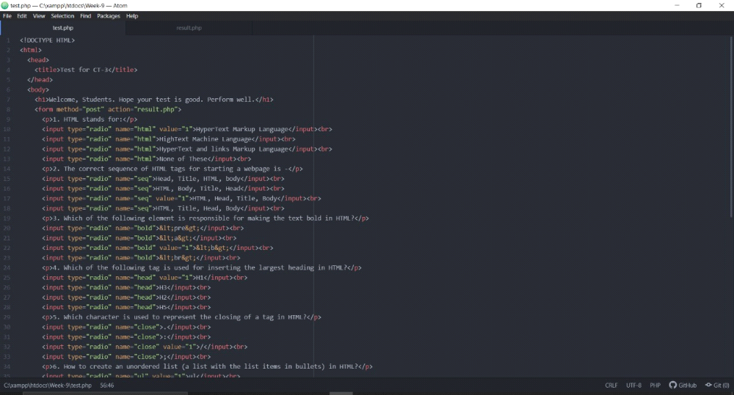
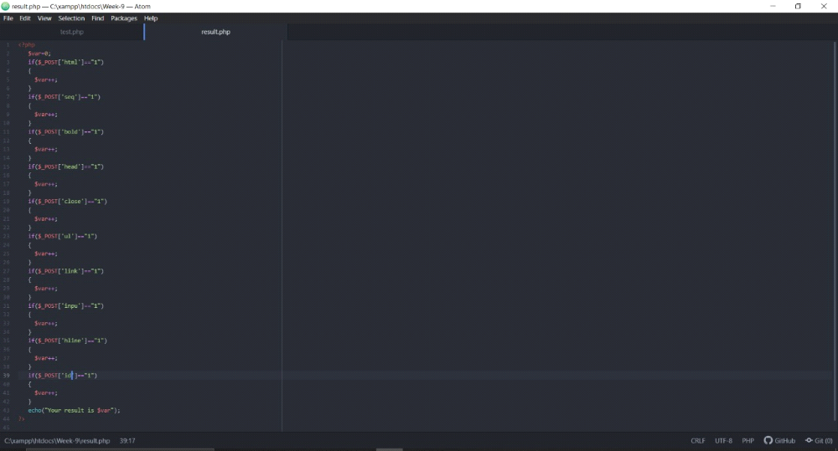

Output:
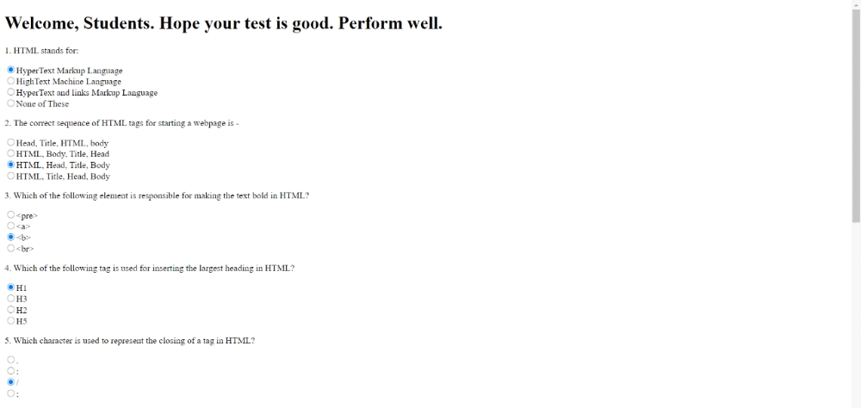
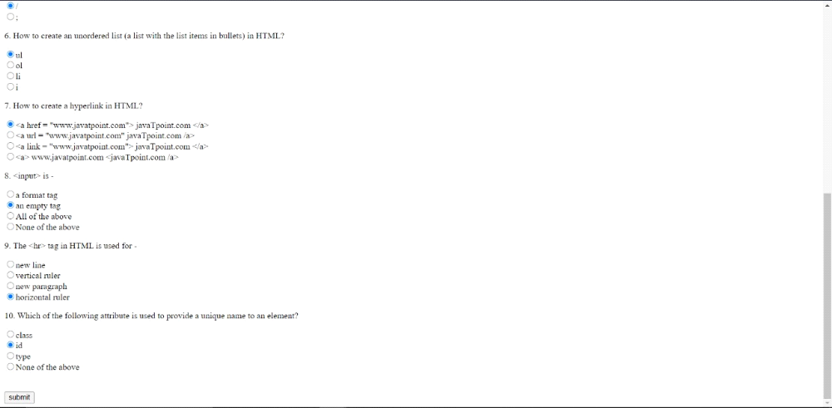
Result: A simple online test web page in PHP was developed successfully

